Name: Prerna Deepak Gyanchandani Roll No.: 25KSMSCCS06 Date: 1/4/26

Wireless Sensor Networks (WSN)

Practical 1

Aim: Demonstrating Distributed Layer Function.
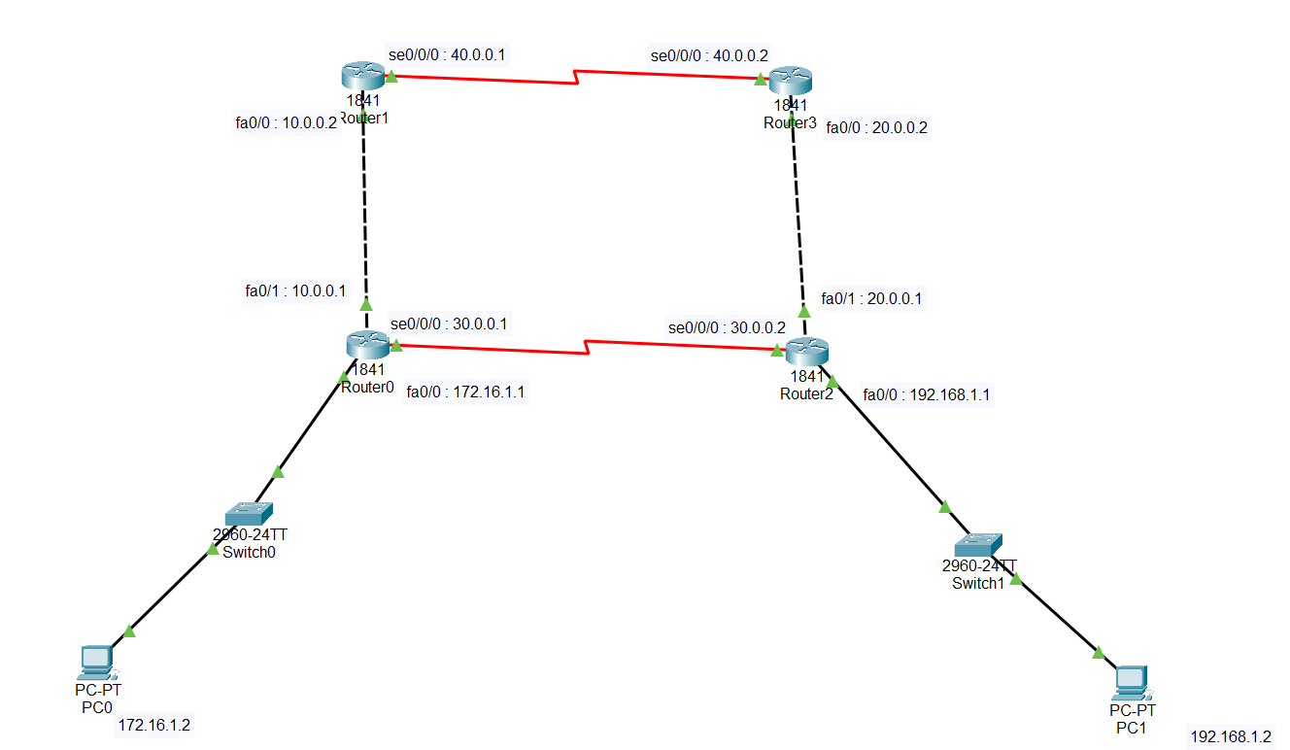
Step 1:
- Place the components
- Add port to router HWIC 2T
- Make the connections (PC-Switch-Router :Copper straight through ; Router -Router : Copper cross over and between opposite router : Serial DCE)
- Add IP address to PC
For each Router add HWIC-2T module
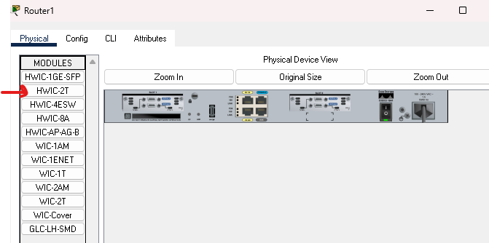
Step 2:
- Configure the interface of Router
- Router0 – click – config – interface fa0/0(172.16.1.0) – interface fa0/1(10.0.0.0) and serial0/0/0 (30.0.0.1) assign IP address and ON the port
- Router1 – click – config – interface fa0/0(10.0.0.0) and serial0/0/0 (30.0.0.1) assign IP address and ON the port
- Router2– click – config – interface fa0/0(192.168.1.0) – interface fa0/1(20.0.0.1) and serial0/0/0 (30.0.0.2) assign IP address and ON the port
- Router3 – click – config – interface fa0/0(20.0.0.2) and serial0/0/0 (40.0.0.2) assign IP address and ON the port
Step 3:
- Router – click – RIP – CLI – version 2
- Click RIP – add network
R0 : 172.16.0.0 ; 10.0.0.0 ; 30.0.0.0
R1 : 10.0.0.0 ; 30.0.0.0
R2 : 192.168.1.0 ; 20.0.0.0 ; 30.0.0.0
R3 : 20.0.0.0 ; 40.0.0.0
- Check the connectivity.
Step 4:
- In the simulation filter the value with RIP (Edit filter; unselect all the values from all the tab and keep on RIP)
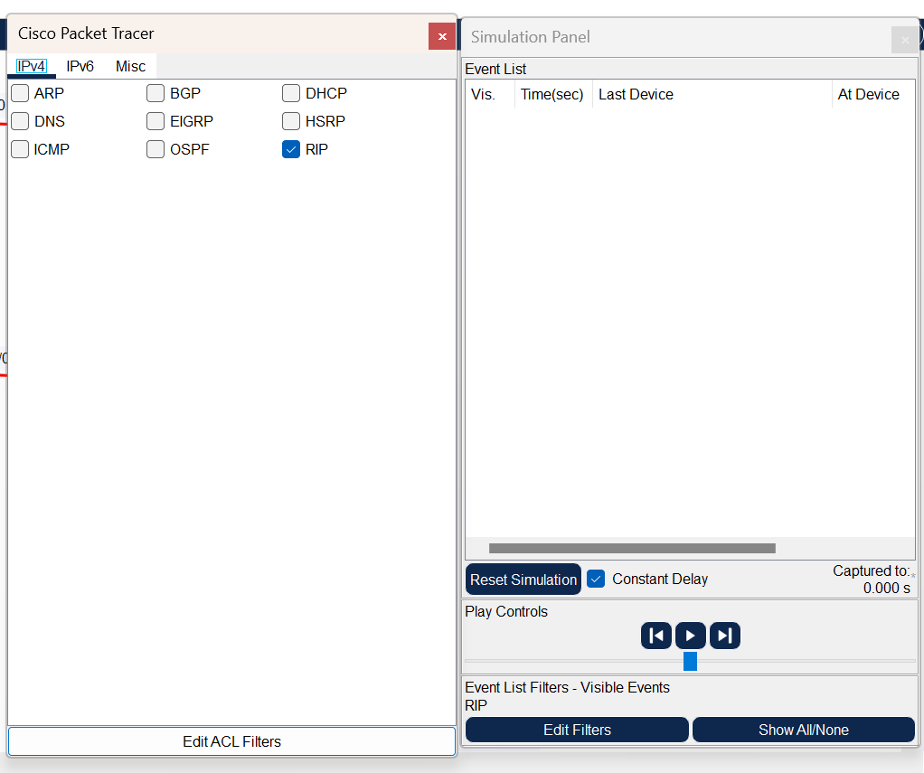
Name: Prerna Deepak Gyanchandani Roll No.: 25KSMSCCS06 Date: 1/4/26

Wireless Sensor Networks (WSN)

Practical 2

Aim : Placing ACL (Access Control List).
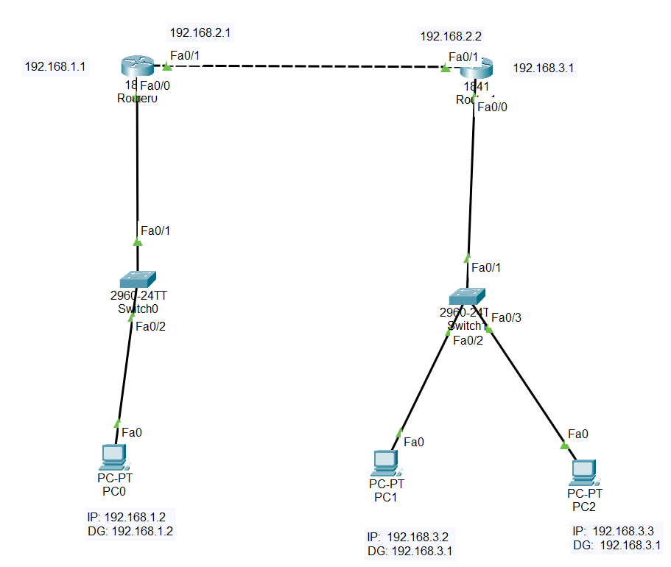
Step 1:
- Place the components
- Make the connections (Router – Router : Copper Cross Over ; Other devices : Copper Straight through)
- Give IP address to the system.
Step 2:
- Configure interface fa0/0 and interface fa0/1
Router R0:
Router>en
Router#conf t
Router(config)#int f0/0
Router(config-if)#ip add 192.168.1.1 255.255.255.0
Router(config-if)#no shut
Router(config-if)#int f0/1
Router(config-if)#ip add 192.168.2.1 255.255.255.0
Router(config-if)#no shut
Router(config-if)#exit

Router R1:
Router>en
Router#conf t
Router(config)#int f0/0
Router(config-if)#ip add 192.168.3.1 255.255.255.0
Router(config-if)#no shut
Router(config-if)#int f0/1
Router(config-if)#ip add 192.168.2.2 255.255.255.0
Router(config-if)#no shut
Router(config-if)#exit

- Configure static route for routers
R0 : ip route 192.168.3.0 255.255.255.0 192.168.2.2
R1 : ip route 192.168.1.0 255.255.255.0 192.168.2.1

Step 3:
- Configure ACL
- We should not allow source PC 192.168.2.101 to access the network 192.168.1.1
- As we are working on standard ACL, it should be configured near the destination, so we are going to configure on fa0/1 on Router R0
- Create access-list
- Apply the access-list to an interface
Router(config)#access-list 1 deny 192.168.3.3 0.0.0.0
Router(config)#access-list 1 permit any
Router(config)#int fa0/0
Router(config-if)#ip access-group 1 out
Router(config-if)#

Step 4:
Check the connectivity.

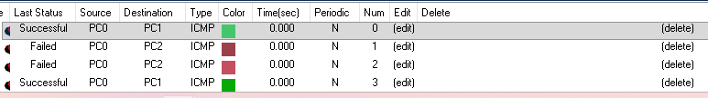

Name: Prerna Deepak Gyanchandani Roll No.: 25KSMSCCS06 Date: 1/4/26

Wireless Sensor Networks (WSN)

Practical 3

Aim : Planning Network-based Firewall.
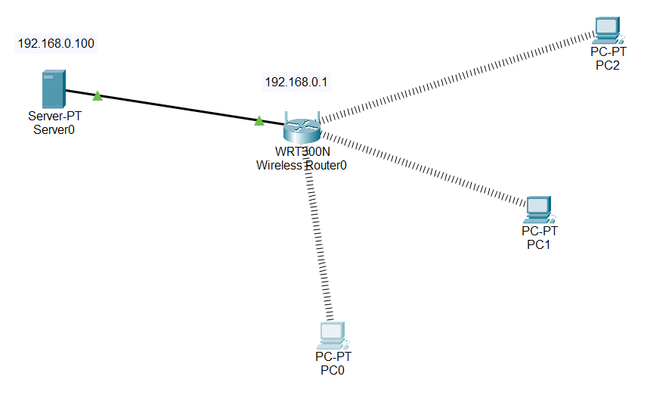
Step 1:
- Place the components.
- Click the wireless router-> in GUI check the IP address -> no change in the settings is done.
- Connect Copper straight through wire between server and wireless router(ethernet 1). Wait till the connection is ON(green).
For each pc add WMP300N module:
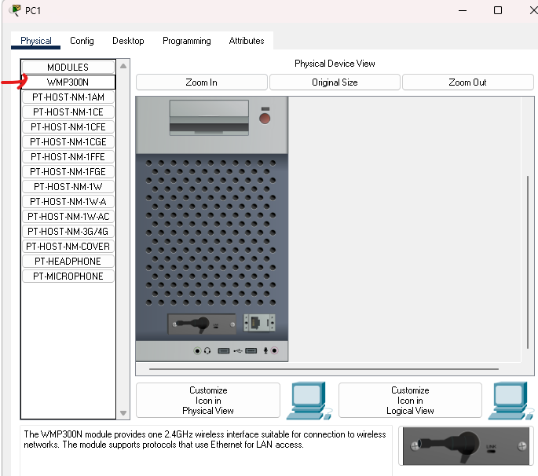
Step 2:
Click server -> desktop ->IP address -> DHCP -> auto IP will be provided.
Step 3:
Add the wireless interface to the PC.
Step 4:
Check the connectivity between PC and server
(PC – server : ping 192.168.0.100) ICMP
Desktop -> web browser -> url: 192.168.0.100 -> connectivity is shown IP
Step 5:
We need to block the ICMP protocol i.e. ping command
Click the server -> desktop -> IPv4 Firewall ->
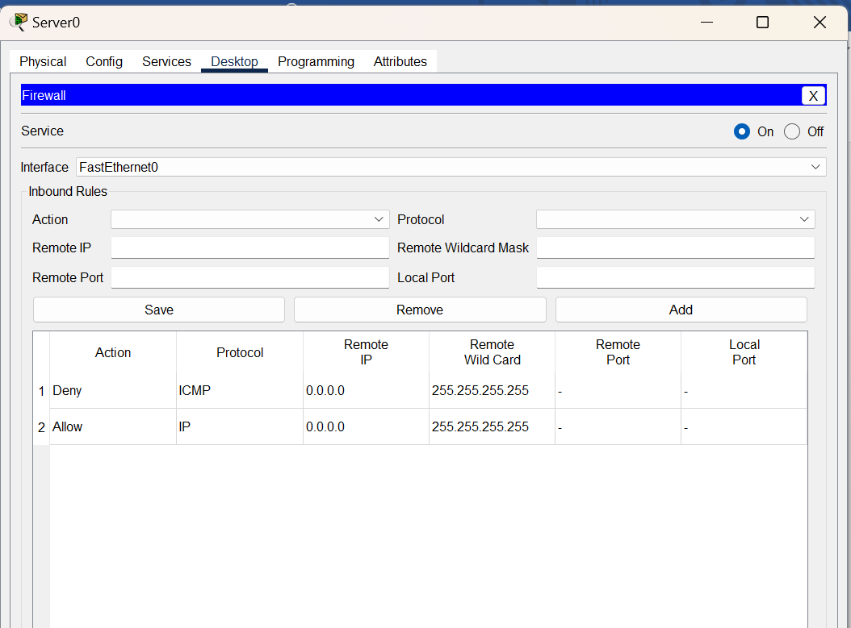
Make services ON
- Action : deny Protocol : ICMP Remote IP : 0.0.0.0 Remote Wildcard Mask : 255.255.255.255 Add
- Action : allow Protocol: IP Remote IP : 0.0.0.0 Remote Wildcard Mask : 255.255.255.255 Add
Step 6:
Now check the connectivity from PC to server.
Through ping command we will not be able to connect the server whereas through web browser url we can access the server from PC
Through ping: Through ip protocol:
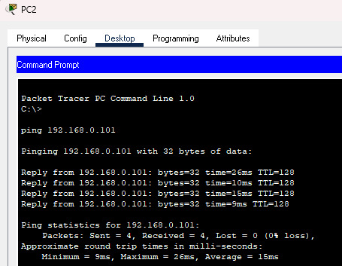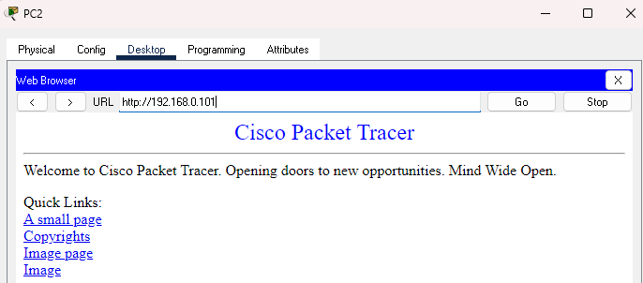

Name: Prerna Deepak Gyanchandani Roll No.: 25KSMSCCS06 Date: 1/4/26

Wireless Sensor Networks (WSN)

Practical 4

Aim : Creating an Adhoc Network.
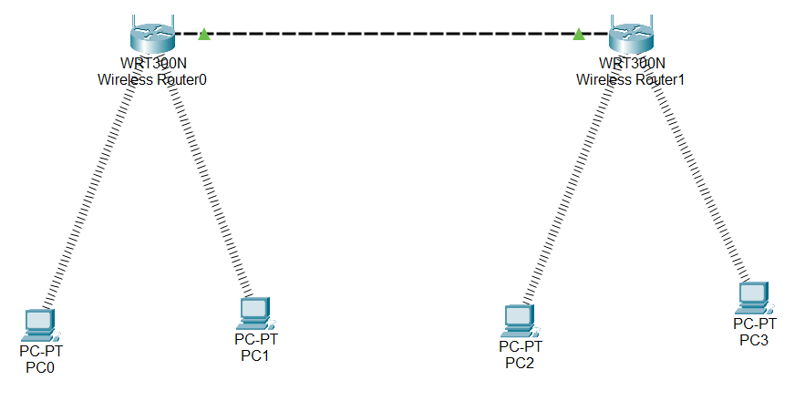
Step 1: Add two wireless router
Connect two router through copper cross over via Ethernet
Step 2: configure the wireless router.
Set SSID as CS and IT (save settings)
In wireless security set security mode to WPA2 Personal and set passphrase (eg: ciscorouter1) (save settings)
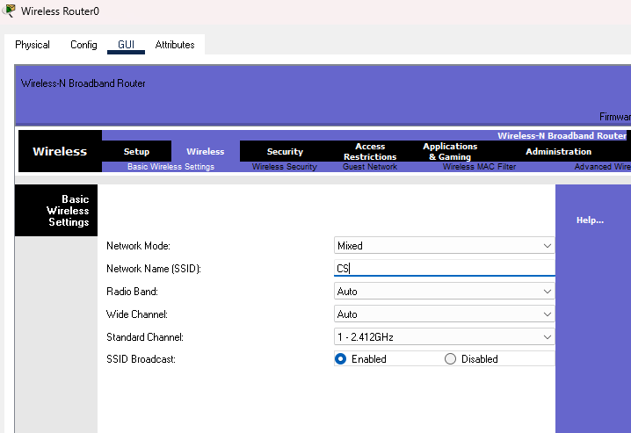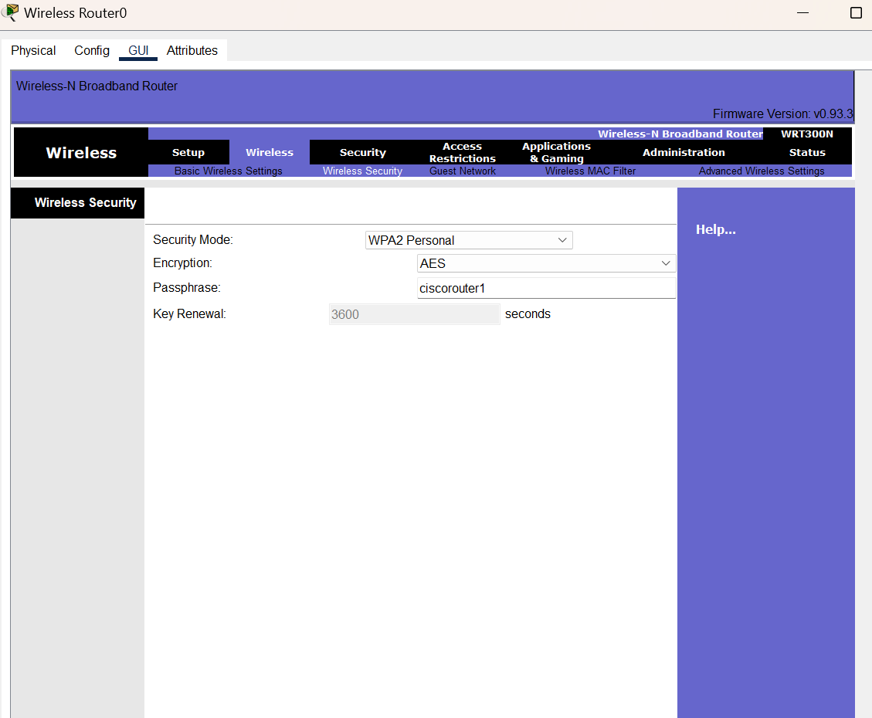
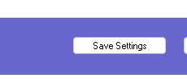
In admistration set remote access as enabled.
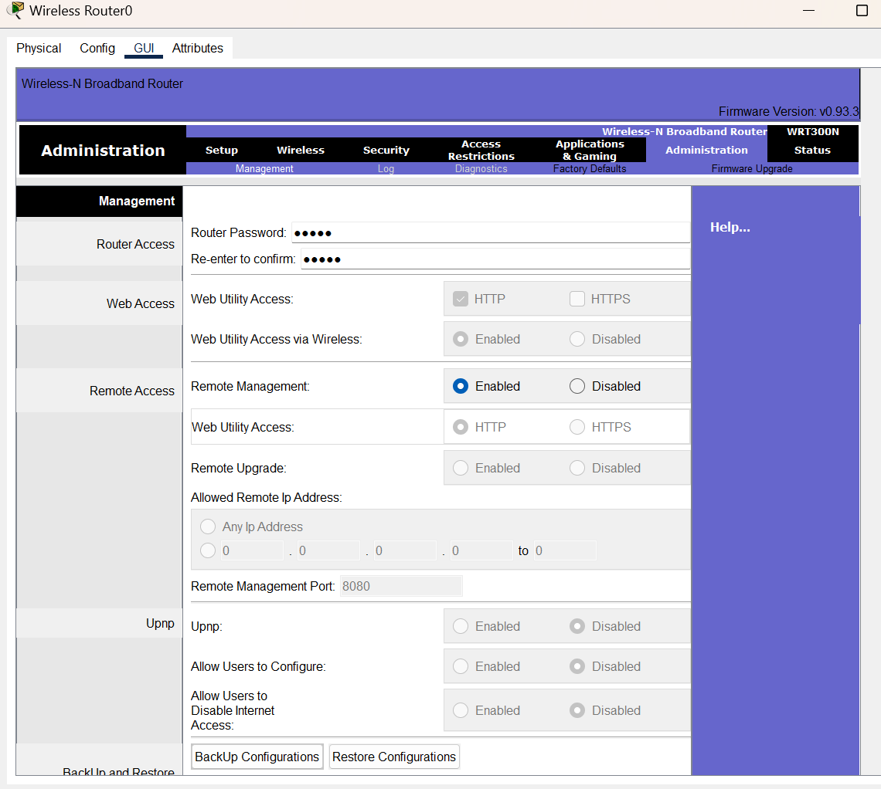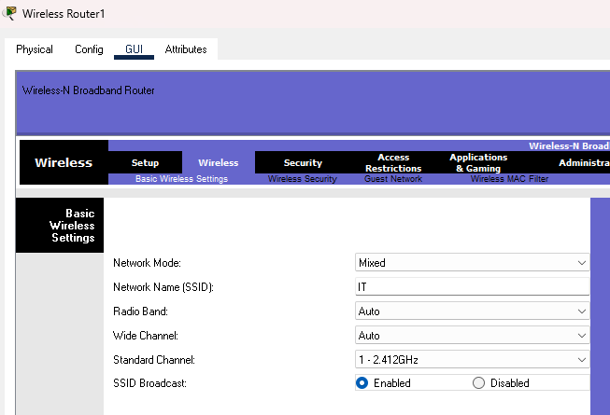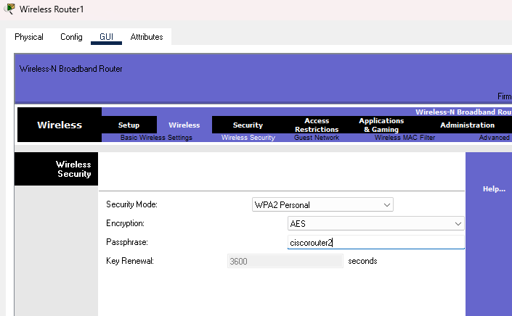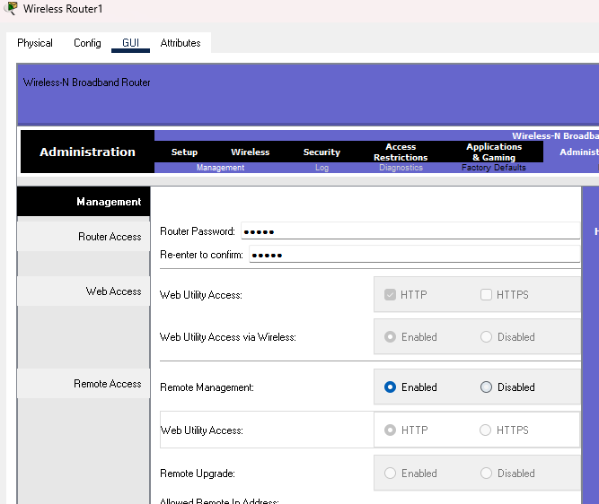
Name: Prerna Deepak Gyanchandani Roll No.: 25KSMSCCS06 Date: 1/4/26

Wireless Sensor Networks (WSN)

Practical 5

Aim: Configuring Basic AP Settings.
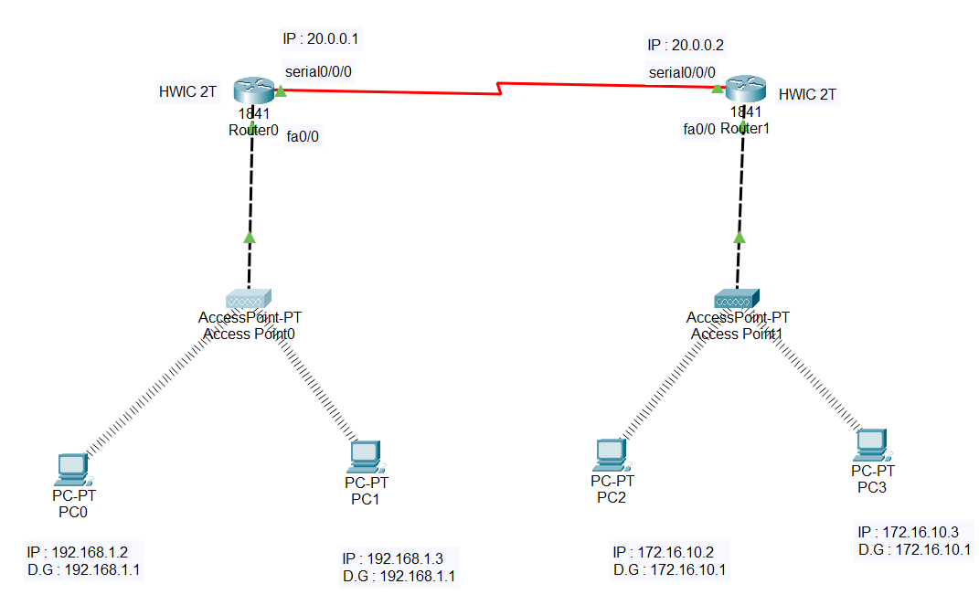
Add WMP300N module to pc and HWIC-2T module to router
Step 1 : Add two access point
Configure the access point( select access point – config – port 0 – status – ON)
Select access point – config – port 1 – status – ON – SSID – CS – WPA2-PSK – pass phrase – ciscopacket1)
Repeat same for other access point where SSID – IT and pass phrase as ciscopacket2
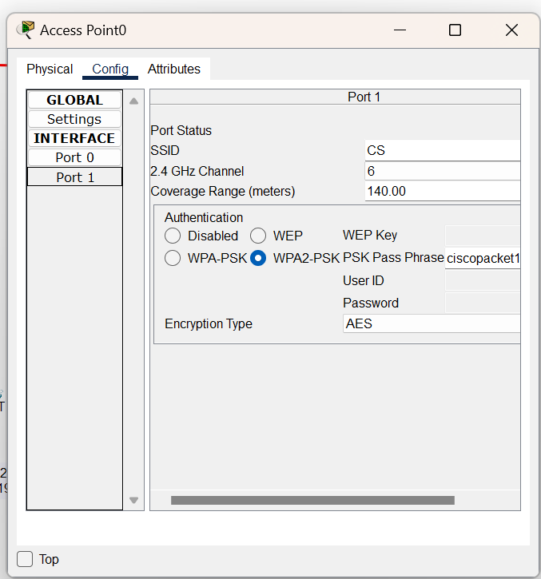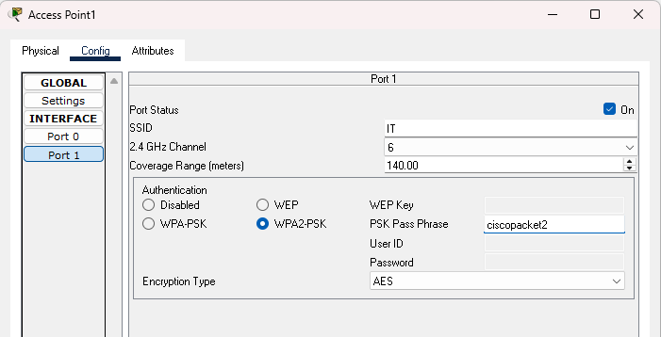
Step 2 : Add end devices
Give IP address to the end devices.
Add the wireless module to the PC (turn off PC- remove existing module and add wireless module)
Select PC – Config – Wireless0 – SSID – CS and passphrase – ciscopacket1
Repeat same for other PC
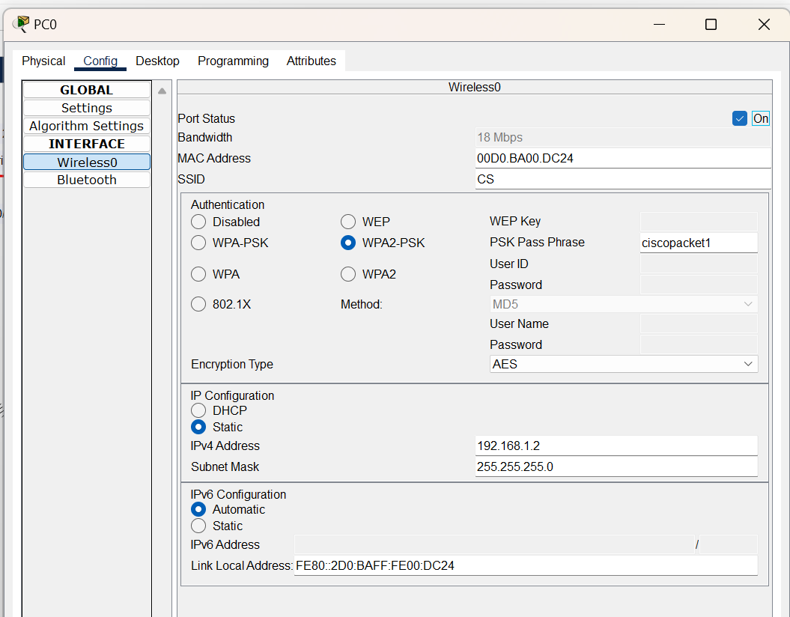
Step 3 : Add two router 1841
Connect AP-Router copper cross over through wire fa0/0
Click on router – config – fast ethernet 0/0 – port ON – IP address -192.168.1.1
Same with other router.
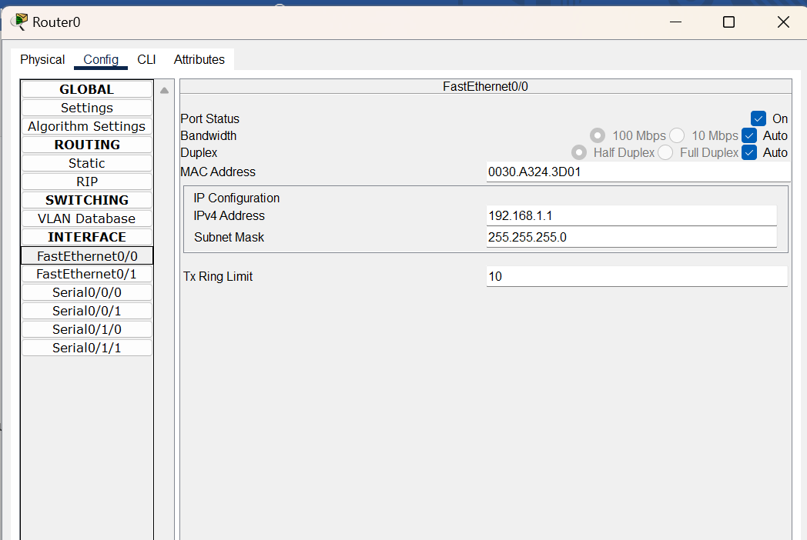
Connect Router-Router serial wire serial0/0/0
Click on router – config – serial0/0/0 – port ON – IP address -20.0.0.1 (other router 20.0.0.2)
Same with other router.
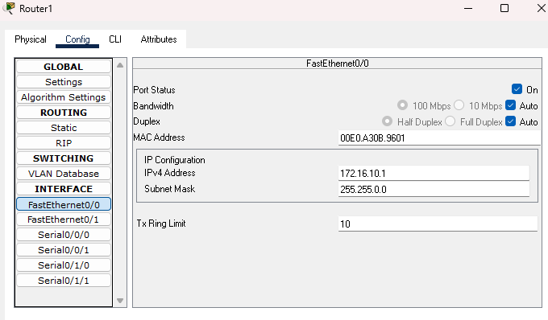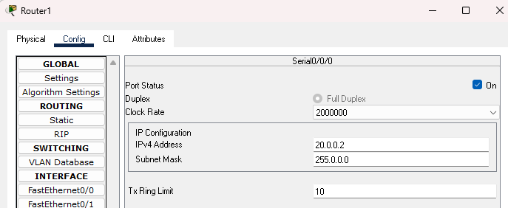
Step 4: click on router – config – RIP -add two network i.e. 20.0.0.0 and 192.168.0.0
Repeat same for other router 20.0.0.0 and 172.16.0.0
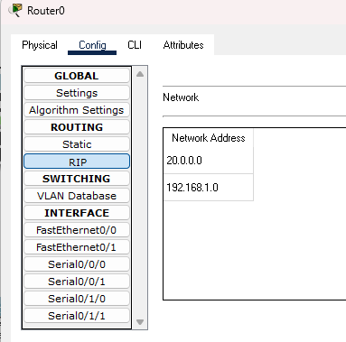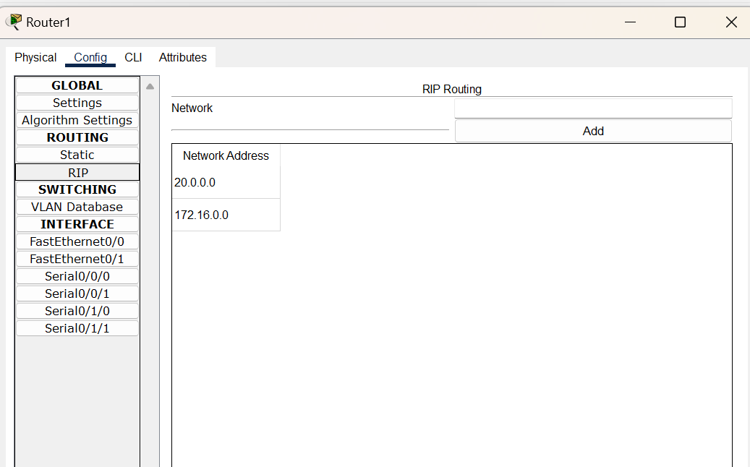
Step 5 : Click on PC – desktop – IP address and check if it is static or dynamic.
If dynamic then change to static and give IP address.
Step 6 : Check the connectivity.

Name: Prerna Deepak Gyanchandani Roll No.: 25KSMSCCS06 Date: 1/4/26

Wireless Sensor Networks (WSN)

Practical 6

Aim : Configure Ethernet/Fast Ethernet Interfaces.
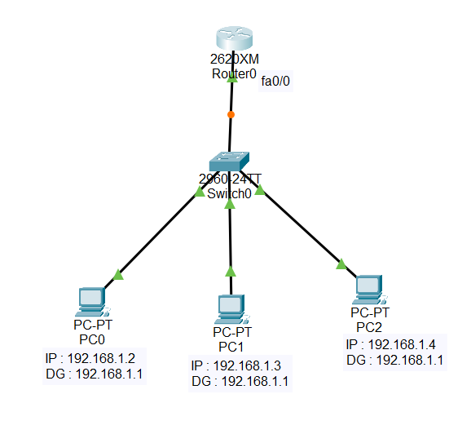
Step 1: Add the components (Router : 2620, Switch: 2960, End devices)
Step 2: Make the connections with copper straight through wire
Step 3: Give IP address to the end device.
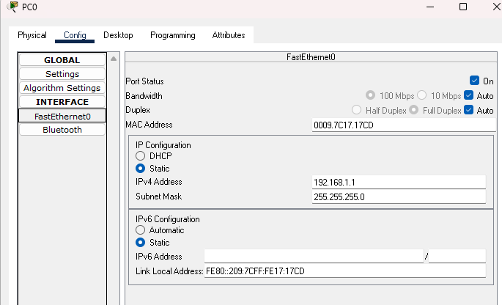
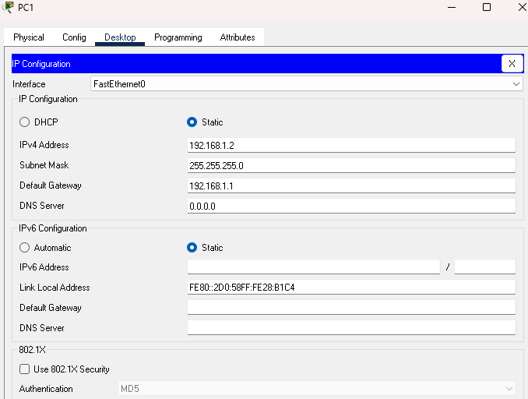
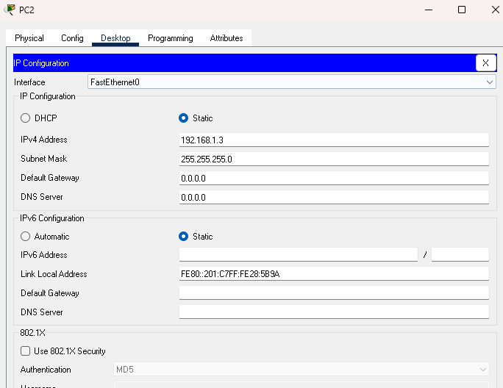
Step 4: Configure the router (Router – CLI)
Router>en
Router#conf t
Router(config)#int fa0/0
Router(config-if)#ip address 192.168.1.1 255.255.255.0
Router(config-if)#no shutdown
Router(config-if)#exit
Step 5: Check the connectivity between Router and PC and between PC and PC
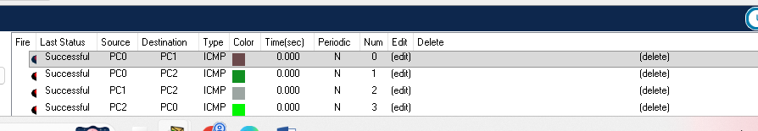
Name: Prerna Deepak Gyanchandani Roll No.: 25KSMSCCS06 Date: 1/4/26

Wireless Sensor Networks (WSN)

Practical 7

Aim: Configure Radio Interface through GUI.

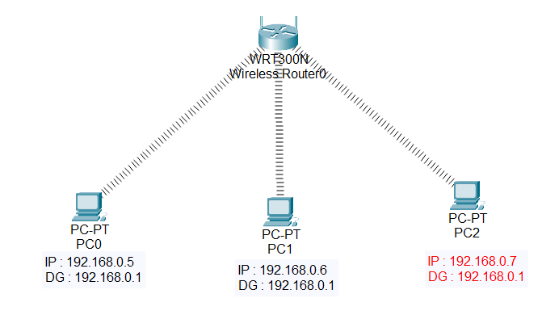
Step 1: Add components (wireless router: WRT300 and end devices)
Step 2 : Give IP address to end device
Step 3 : Configure wireless router
Select the router – GUI – setup - DHCP server – disable - save
Check the IP address
Go to router – wireless – basic wireless service – SSID (Home) - save
Go to router – wireless – wireless security – security mode – WEP – key 1 :0123456789 - save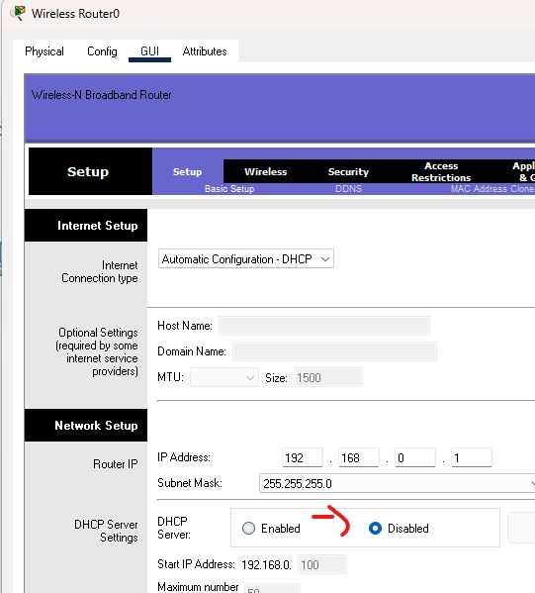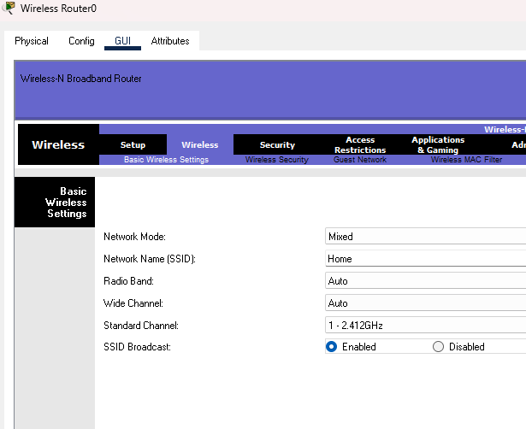
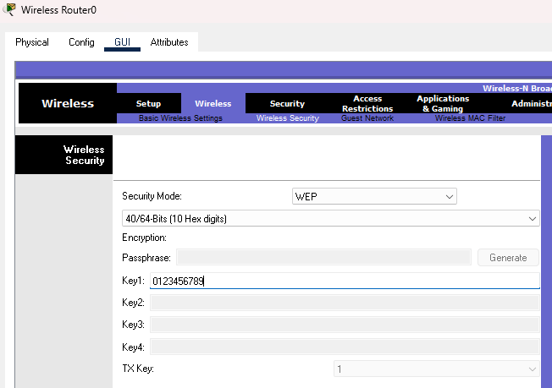
For each pc:
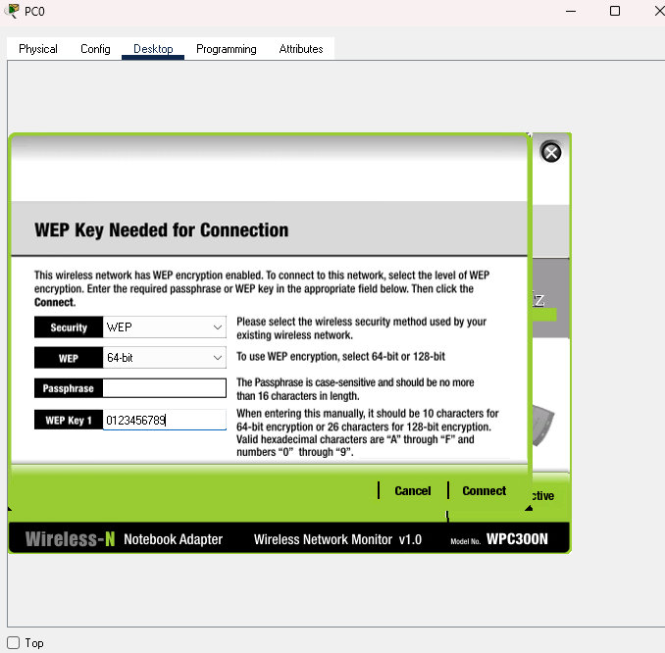
Step 4 : Click on PC, add the wireless interface WMP300 module.
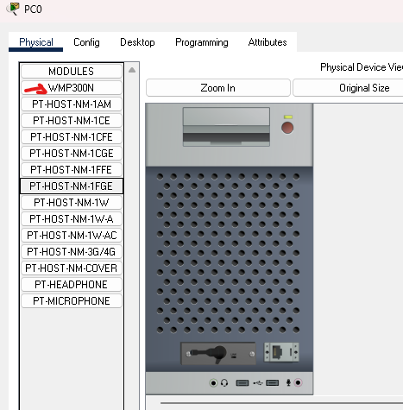
Step 5: Click PC – Desktop – Wireless PC- Connect – Refresh – Select network – give key – connect.
Step 6 : Check the connectivity.
